***@BANK AND INVESTMENT ACCOUNT MANAGEMENT***

**BUSINESS MODEL DOCUMENT**

***Date:*** *14/08/2022.*

*Presbyterian Printing Press Limbe,*

*PPP Plc, Cameroon.*

|  |  |
| --- | --- |
| ***Document Property*** | ***Information*** |
| *Document Ref:* |  |
| *Date of Creation:* |  |



1. **PROBLEM STATEMENT**

In a community of People and the Bank, people own bank accounts for two reasons, either to just save their money or to invest their money or for both reasons on a separate record-line (Savings Account and Investment Account). Under saving accounts, cash can be deposited and withdrawn at anytime during the bank’s working hours. Withdrawals via the ATM machine operates on a 24/7 basis for the savings account. Under Investment accounts, the investor agrees with the bank on the date of refund and withdrawals can only be done on or after that date. Monthly interest rate will be determined by the bank depending on the amount of money invested and duration of investment. All activities of these accounts should be operational and accessible via a modulated mobile app that connects to MTN and Orange Mobile money accounts which permits both deposits and withdrawals from the bank.

The Bank should have a manager and customer service modules to manage and monitor the operations of as above.

* 1. **About the Document**
  2. **System Value Added**

The system will permit clients of the bank to monitor their savings and investment accounts on their phone such that they can do both deposits and withdrawals on their saving accounts using their phones linked to a mobile money account. Also, the system will permit clients to do investments using their mobile money and will permit withdrawals of dividend when due and can be able to withdraw their capital investment after the committed period. Access view to the bank’ portfolio will be permitted to investors only. Furthermore, all documentations will be permitted online such that a scanner will scan the finger print at every relevant transaction. Hence, avoiding frequent desk transaction.

* 1. **Key Partners and Key Resources**
  2. **Market Solution**

This solution is to increase flexibility in banking and information asymmetry in investments which are the core issues with our today’s financial system.

1. **SYSTEM ARCHITECTURE**

This section will defined the structural plan of the entire system.

* 1. **System Key Activities**

Key activities will include account creation, deposits, withdrawals, information display and dividend.

1. **Account Creation:** This is registration of clients into the bank’s system by initializing either a savings account or an investment account.
2. **Deposits:** This is the act of putting money into either of the both accounts by the client. This increases the amount of money the bank will owe the client. This also entails payment received into the account from another account within the bank or out of the bank.
3. **Withdrawal:** This is the direct opposite of deposit activity. It is the act of removing money from either of the both accounts by the client. This reduces the amount of money the bank will owe the client. This also entails the payment/transfer of money out of an account to another account within or out of the bank.
4. **Information Display:** This is the system activity of making information concerning both savings and investment account accessible to clients.
5. **Dividend Activity:** This activity will calculate the monthly dividends of the investment account and credit the dividend subaccounts of the investment holders to permit them do withdrawals of dividend during commit period or reinvestment of dividend after commit period
   1. **System Modelization**

This shows the structural design and functionalities of the system.

1. **Use Case Diagram**

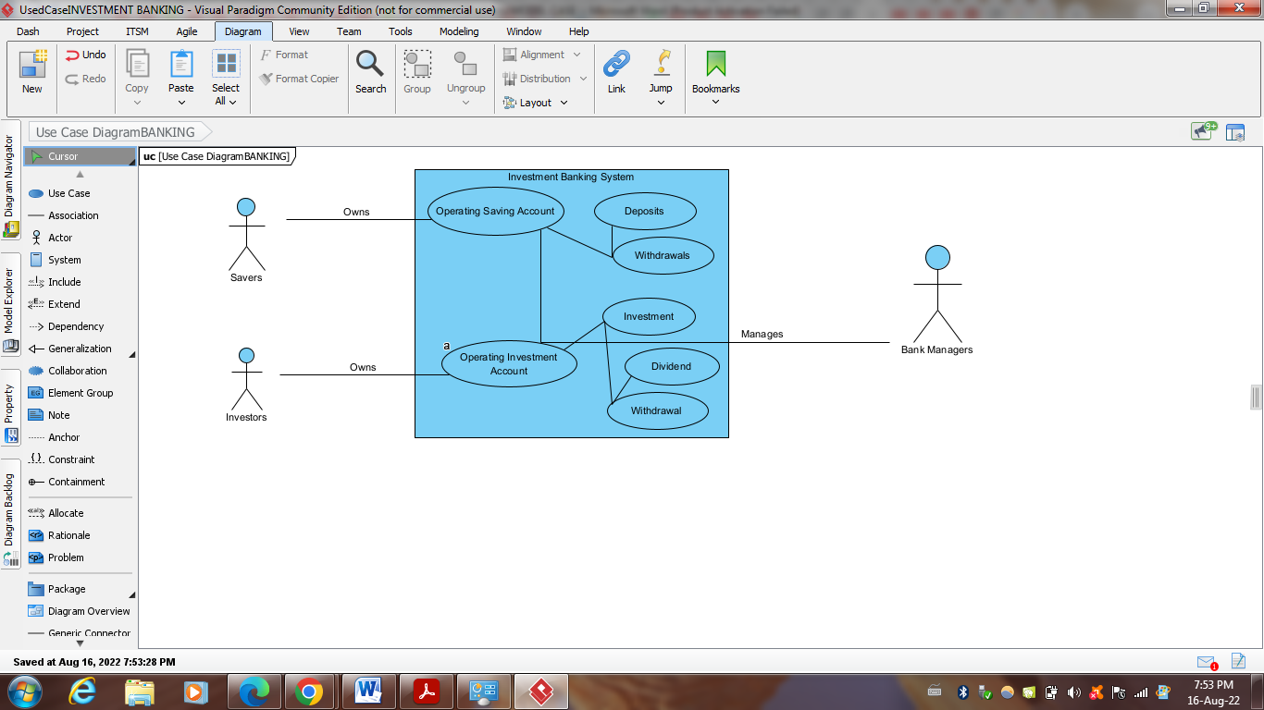

1. **Activity Diagram**
   1. **System Components**

These are the utilities needed for the smooth functioning of the system. This includes

1. **Data Servers**: These are computers with high system functionalities that stores and track system data and provides data for the view of system users.
2. **Clients:** These are both savers operating savings accounts and investors operating investment accounts. A single client can have both savings and investment accounts at the same time. They will be able to use their mobile phones to view information concerning their accounts from the Data servers and will be able to launch deposit and drawings transactions via their mobile phones.
3. **Bank Managers:** These are the bank workers who ensure the smooth running of the system. They monitor clients’ accounts and makes possible for all clients commands to be successful.
4. **FINANCIAL MODEL**
   1. **Main Financial Keys:** 
      1. **Cost/Cash outflow:** These are the financial keys that lead to outflow of money from the hands of the investment banking owners. This will include
5. Physical premise rental cost,
6. Acquisition and installation of data servers,
7. Marketing Cost,
8. Dividend,
9. External Platform support charges (MTN, Orange Money etc),
10. Administrative cost (Salaries, electricity etc).
    * 1. **Revenue/Cash inflow:** These are the financial keys that lead to inflow of money to the hand of the investment banking owners. This will include,
11. Return on Investment (ROI) from the Bank’s investment portfolios on projects invested in by the bank with the investment fund and part of the savings fund.
12. Withdrawal charges via external platforms.
13. Charges for payment/transfer intermediary service.